**GREENHOUSE AUTOMATION**

-Fazalulrehman A Belwadi

**CONTENTS**

|  |  |
| --- | --- |
| SL NO | TITLE |
| i | Abstract |
| 1 | About greenhouse automation |
| 2 | Requirements |
| 3 | Block diagram and description |
| 4 | Architecture |
| 5 | Test plan and output |
| 6 | Output images |
| 7 | Applications |
| 8 | Future scope |
| 9 | References |

**Abstract**

Greenhouse Monitoring and Automation System is the technical approach in which the farmers in the rural areas will be benefitted by automatic monitoring and controlling greenhouse environment. It replaces the direct supervision of the human. Greenhouse is a building where plants are grown in a controlled manner. In general, greenhouses are usually affected by the weather and plant diseases, as a result, their yield can be minimized and thus income is reduced. Through the analysis of the current situation of greenhouses, this system proposes a low-cost solution for identifying of infected plant leaves of agricultural greenhouse. The proposed system is an embedded system which will closely monitor the microclimatic parameters of a greenhouse on a regular basis round the clock for cultivation of crops or specific plant species. The purpose of this work is to design a labor free, sensor-based greenhouse monitoring system. The system comprises of microcontroller and sensors. Since a microcontroller is used as the heart of the system, it makes the set-up low-cost and effective nevertheless and flexible. This embedded system has three sensors, they are temperature sensor, LDR sensor and soil moisture sensor. As the system also employs an LCD display for continuously alerting the user about the condition inside the greenhouse, the entire set-up becomes user friendly. Nowadays due to urbanization and lack of land availability there is a great need to construct the Greenhouses which will be reserved mainly for growing crops

1. **About Greenhouse Automation**

**1.1 Introduction**

A greenhouse is an exceptionally outlined homestead structure building to give a more controllable environment to better harvest generation, crop security, product seeding and transplanting. Also, the accessible space of area for developing yields has been altogether diminishing, following to more space of area is vigorously utilized for housing and commercial ventures as a part of this present-day period. In most tropical nations, the utilization of greenhouse has been developed for cost effective farming i.e. organic products, new blossoms and vegetables generation. The effectiveness of plant creation inside greenhouse depends fundamentally on the conformity of ideal atmosphere development conditions to attain to high return at low cost, great quality and low natural burden. To attain to these objectives a few parameters, for example, light, temperature and humidity, soil moisture must be controlled ideally given certain criteria through warming, lighting, ventilation and water creation. Persistent checking and controlling of these ecological variables gives significant data relating to the individual impacts of the different elements towards acquiring most extreme harvest creation. Greenhouse situations present remarkable difficulties to great control. Temperature changes happen quickly and fluctuate broadly relying upon sun powered radiation levels, outside temperatures and moistness levels in the greenhouse. Poor light intensity and high stickiness frequently bring about poor natural product set and quality. More exact control can decrease heating fuel and electrical expenses, expand the efficiency of laborers by empowering them to go to more important assignments, empowering directors and producers to settle on better administration choices and invest more energy dealing with the procedure.

**1.2 Objectives**

The main objective of this project is to Monitor and Control the Greenhouse by means of measuring and maintaining volumetric water content in soil, Temperature, humidity and finally display all relevant data in LCD

**1.3 SWOT Analysis**

**STRENGTHS**

* Reliability of crop increases in green house cultivation.
* Expands your growing season.
* Expanding the variety among your produce.
* Minimize external threats to your crop.

**WEAKNESS**

* High upfront and operating expenses.
* Lack of pollination.

**OPPORTUNITIES**

* Advancement in Technology.
* Improvements in automation system.

**THREATS**

* Failure of Power supply leads to shut down of whole system.

**1.4 4W's and 1H**

**Who:**

This system is used by Farmers, Gardener, Horticulturist and People who want plant in smaller area

**What:**

This is used to monitor the various activity of Greenhouse.

**When:**

This Greenhouse Monitoring and Automation System is used when special care for the plants or crop is needed.

**Where**:

This Greenhouse Monitoring and Automation System is used in Residential, Commercial and Agriculture domain.

**How:**

This Greenhouse Monitoring and Automation System can bs used by installing various sensor across the green house.

**2. REQUIREMENTS**

**2.1 High level requirements:**

|  |  |
| --- | --- |
| **RID** | **DESCRIPTION** |
| HLR1 | To measure the volumetric water content of the soil |
| HLR2 | Turn on the Motor volumetric water content of the soil decreases |
| HLR3 | To sense the Temperature for increasing and decreasing values |
| HLR4 | To detect the day or night |
| HLR5 | To operate pump when desired |
| HLR6 | To detect entrance and exit of any visitor |
| HLR7 | Display all measured value in LCD |

**2.1 Low level requirements:**

|  |  |
| --- | --- |
| **RID** | **DESCRIPTION** |
| LLR1 | Should Turn on the LED when temperature increases beyond threshold |
| LLR2 | Notify the water content of the soil using LED |
| LLR3 | Notify the entrance and exit of any visitor through LED |
| LLR4 | Control the lights of the greenhouse |

**3. BLOCK DIAGRAM AND DISCRIPTION**

**3.1 Block diagram**

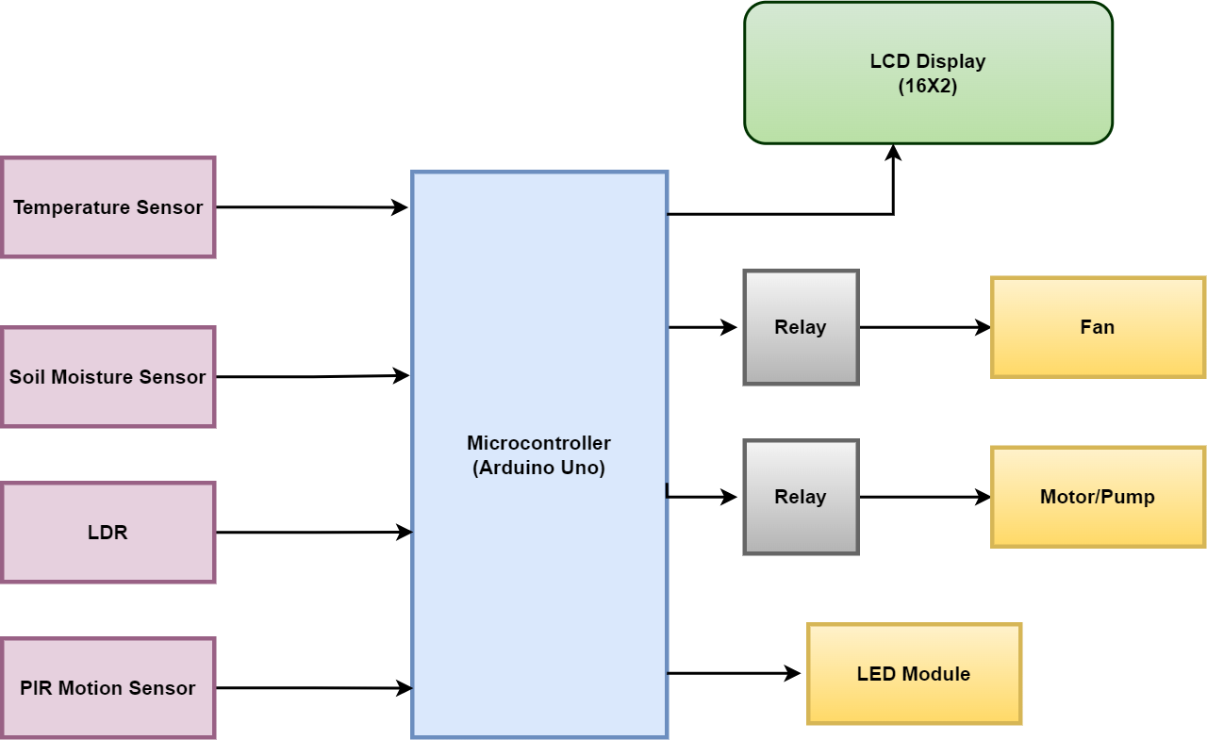

**3.2 Block Diagram Description**

**Microcontroller:**

A microcontroller (MCU for microcontroller unit) is a small computer on a single metal-oxide-semiconductor (MOS) integrated circuit (IC) chip. A microcontroller contains one or more CPUs (processor cores) along with memory and programmable input/output peripherals**.** The **Arduino UNO** is the best board to get started with electronics and coding. If this is your first experience tinkering with the platform, the UNO is the most robust board you can start playing with. The UNO is the most used and documented board of the whole Arduino family.

**Relay** A relay is an electrically operated switch. It consists of a set of input terminals for a single or multiple control signals, and a set of operating contact terminals.

**LCD Display:**

LCD stands for Liquid crystal display. 16×2 LCD is named so because it has 16 Columns and 2 Rows. A character LCD is interfaced to the controller to display the ambient temperature and moisture level of the soil.

**Temperature Sensor:**

A temperature sensor is a device, usually an RTD (resistance temperature detector) or a thermocouple, that collects the data about temperature from a particular source and converts the data into understandable form for a device or an observer. LM35 is a popular temperature sensor. The sensor has three terminals.

**Soil Moisture Sensor:**

The moisture sensor measures the volumetric water content of the soil with the help of a sensing probe which must be put into the soil. The sensor module operates between voltages of 3.3 V to 5V.

**LDR Sensor:**

The LDR sensor is used to detect day or night in this circuit. The LDR sensor is two-terminal light sensitive resistor.It is connected as a voltage divider network at bit 0 of Port A of the Arduino

**PIR Motion Sensor**

PIR sensor or PIR motion sensor is the kind of sensor that measures the Infrared radiations released from objects and thus identify them as moving or still objects.

**LEDs:**

These LEDs are for demonstration purpose to show control of lighting in the garden. In a practical version of the circuit, there could be LED lights controlled through relays by the controller.

**Voltage regulator**

A voltage regulator is a circuit that creates and maintains a fixed output voltage, irrespective of changes to the input voltage or load conditions

**DC Motor:**

A DC motor is interfaced at bit 5 of Port D of the AVR. This motor is for demonstration purpose to show control of water pump by the controller.

**Power Supply:** The circuit can be powered by a battery and 5V regulator IC like 7805.It can also be powered through AC mains by using a step down transformer and rectifier circuit with 7805 voltage regulator.

**4. ARCHITECTURE**

**4.1 Use Case Diagram**

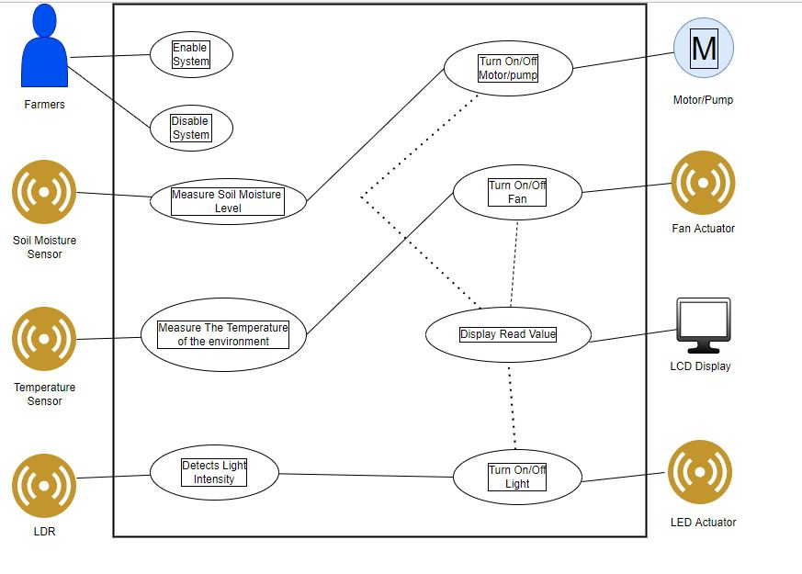

**4.2 Sequence Diagram**

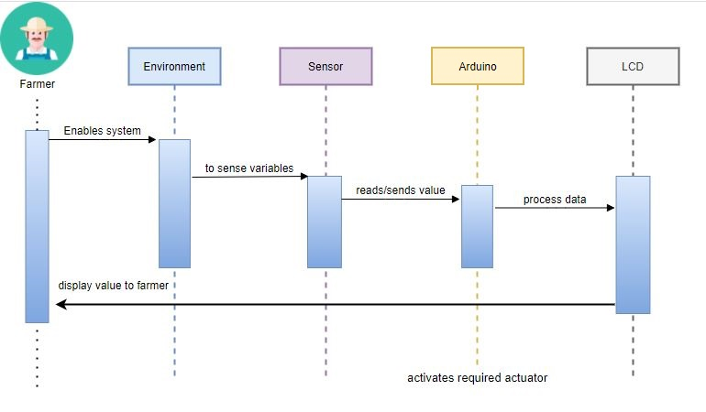

**4.3 Flow Chart**

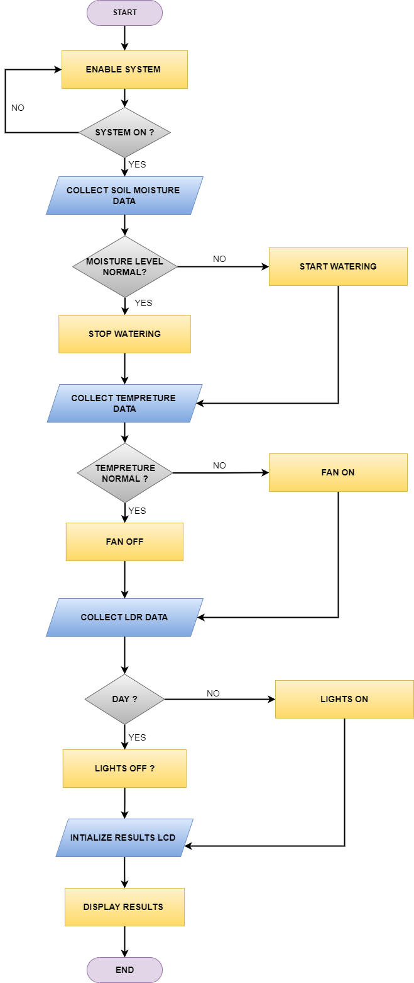

**5. TEST PLAN AND OUTPUT**

# **5.1 High Level Test:**

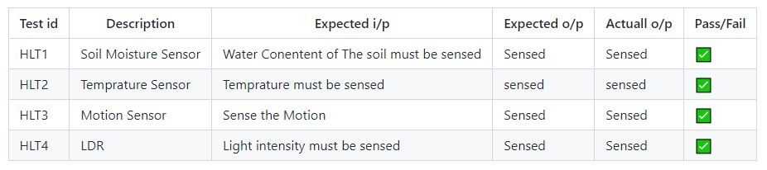

# **5.2 Low Level Test:**

## **Low Level Test for Temperature Sensor (Using Display)**

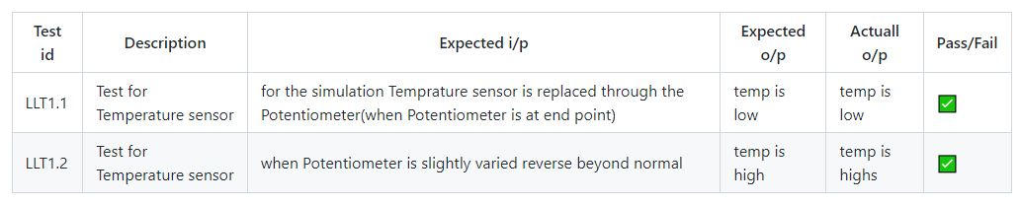

## **Low Level Test for Soil Moisture Sensor (Using Pot)**

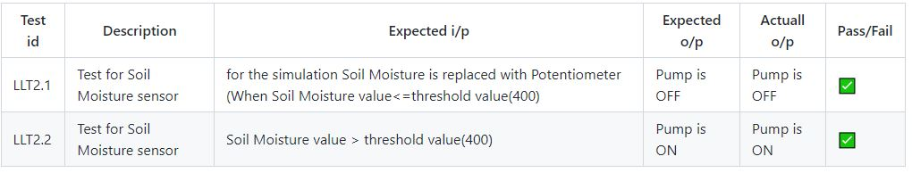

## **Low Level Test for Soil Moisture Sensor (Using Display)**

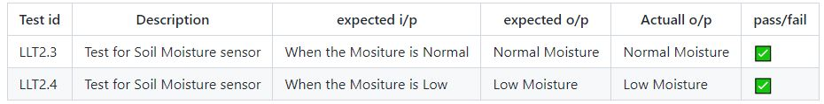

## **Low Level Test for Motion Sensor (Using LED)**

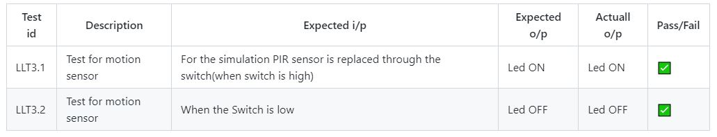

## **Low Level Test for Motion Sensor (Using Display)**

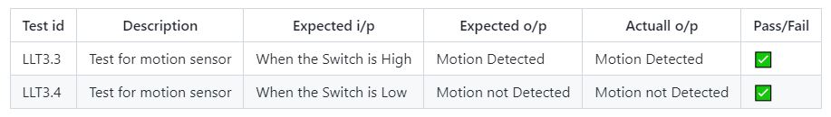

## **Low Level Test for LDR (using Led)**

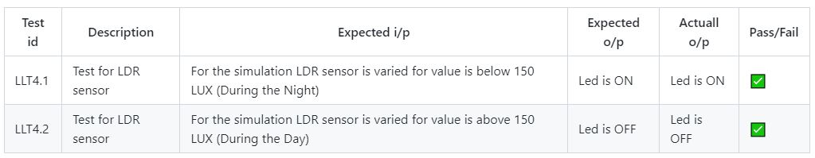

## **Low Level Test for LDR (using Display)**

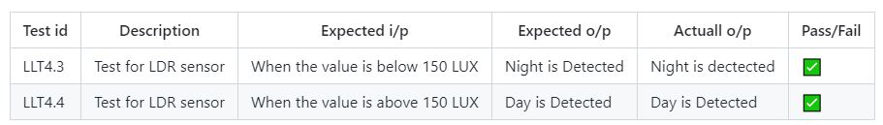

**6 Output Images**

## **Circuit Diagram**

[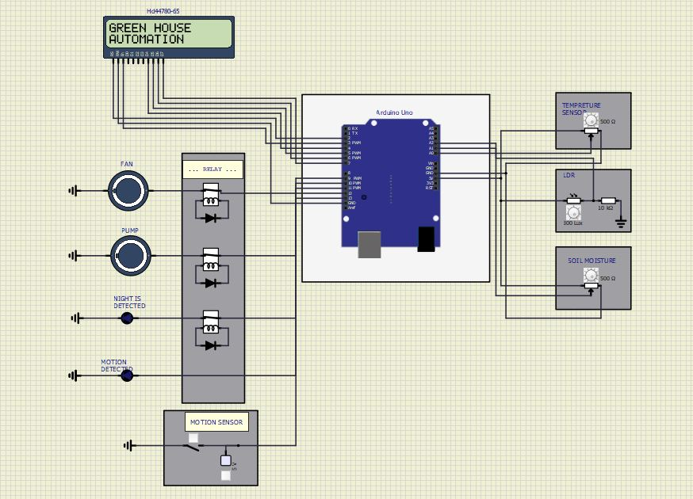](https://user-images.githubusercontent.com/99134492/157268848-bfcd4566-0d1c-497a-b34f-f00fba303416.JPG)

## **Temperature is normal**

[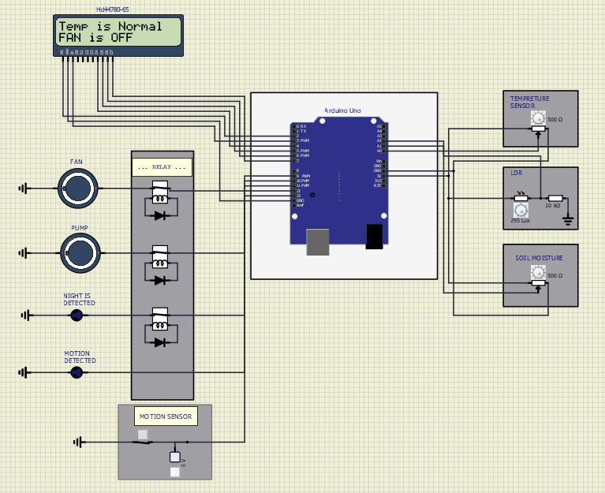](https://user-images.githubusercontent.com/99134492/157268907-bfcad199-38cc-4bd1-afe5-e358849c7323.JPG)

## **Temperature Is High**

[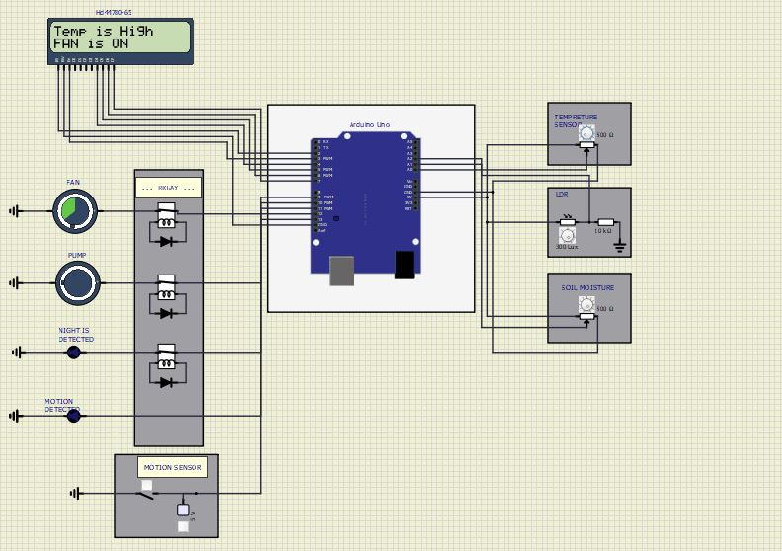](https://user-images.githubusercontent.com/99134492/157268935-478994b4-1bf8-4abe-bee5-0157fabe0175.JPG)

## **Moisture Level Is Normal**

[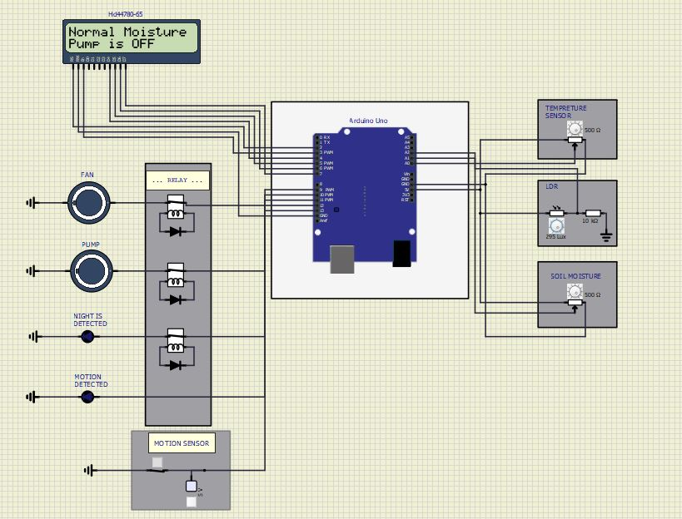](https://user-images.githubusercontent.com/99134492/157268957-72f0a3ce-46c8-42f3-8995-c62982e40e69.JPG)

## **Low Moisture Level**

[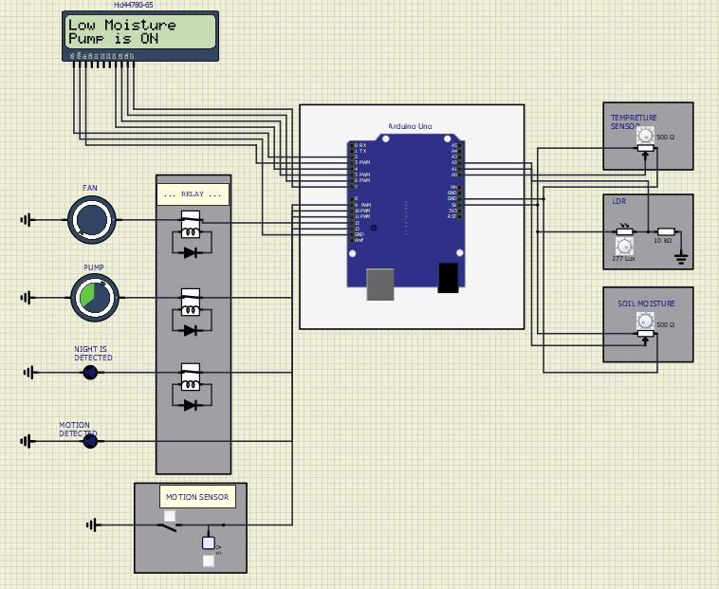](https://user-images.githubusercontent.com/99134492/157268970-f781ce28-06d5-4480-a28a-108418fb51e7.JPG)

## **Day is Detected**

[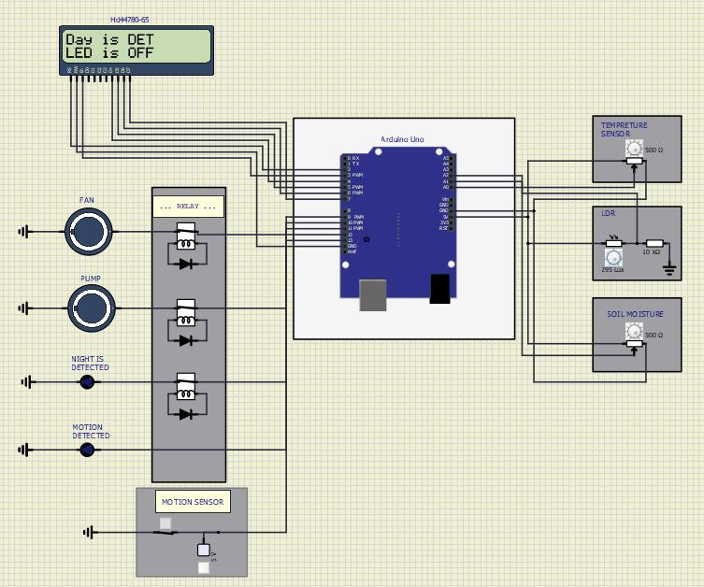](https://user-images.githubusercontent.com/99134492/157268985-e96d4cd4-1e9b-4e77-bd20-19125a6cabd7.JPG)

## **Night Is Detected**

[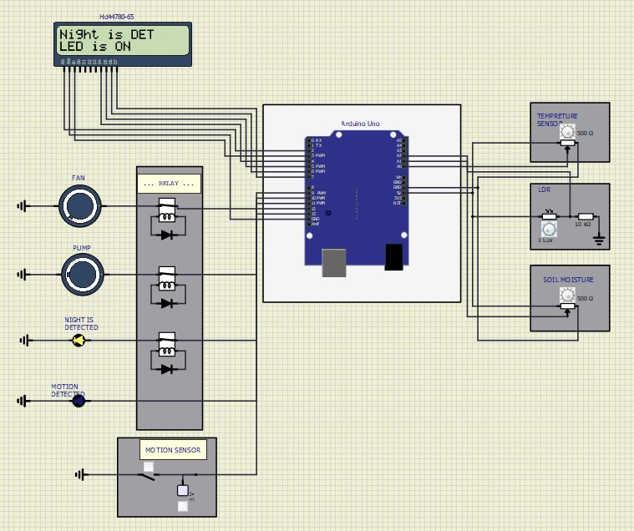](https://user-images.githubusercontent.com/99134492/157269002-3477055e-7256-44c8-94b4-2556ab68244c.JPG)

## **Motion Is Not Detected**

[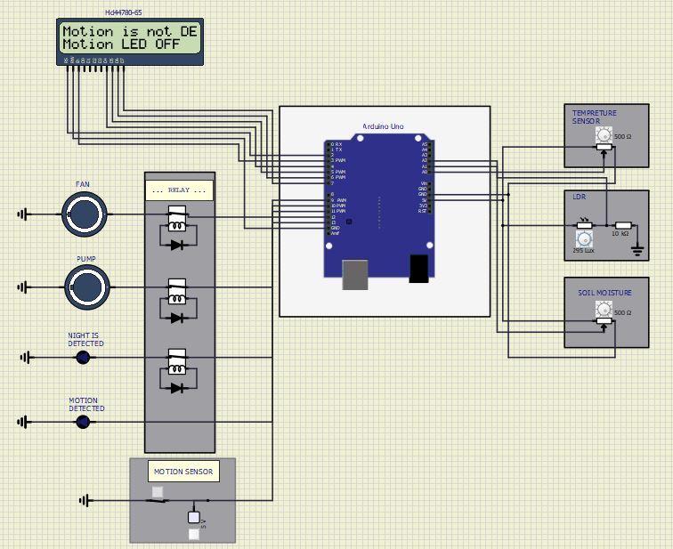](https://user-images.githubusercontent.com/99134492/157269018-78566c9e-e696-4478-b649-7f27ffcbfdbc.JPG)

## **Motion Is Detected**

[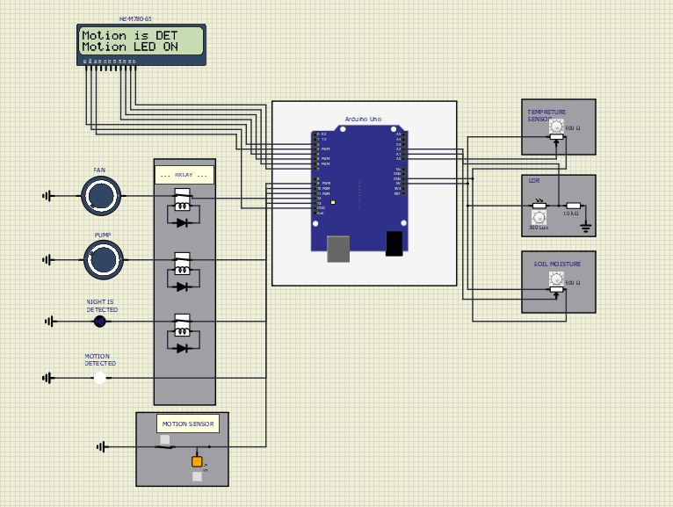](https://user-images.githubusercontent.com/99134492/157269035-a8b08db3-c1bd-47e8-a323-a87196d50066.JPG)

## **When All Sensors Are Triggered At Once**

[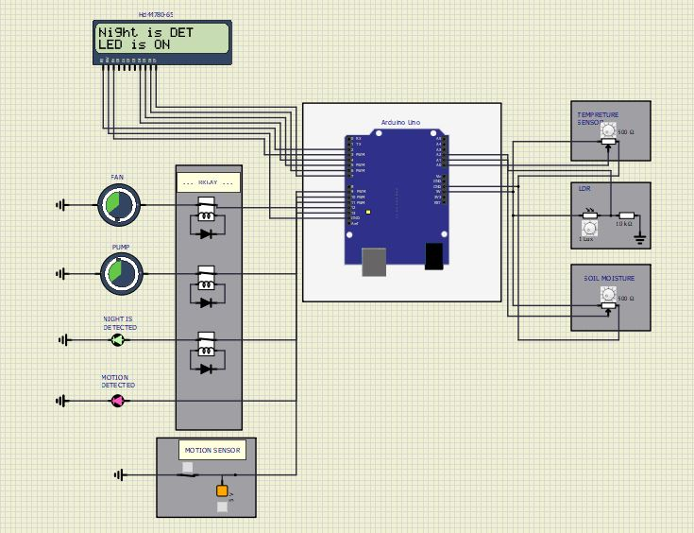](https://user-images.githubusercontent.com/99134492/157269048-88bd4764-7a8d-4896-8740-a4d5a81134cc.JPG)

**7. APPLICATIONS**

* Lightening Systems.
* Rural area Implementation
* Lawn/Gardening management.
* Improved safety and security.
* Air quality and water quality monitoring.
* Better Infotainment delivery.
* Lighting control.

**8. Future Scope**

* The circuit can be improved in many ways and can be used in wide applications. It can be placed and operated in any of the environmental conditions.
* Non-conventional energy sources such as solar panels, wind mills are used to supply power to the automatic greenhouse equipment. The energy produced can be used for automation purpose like in home to control light and fan. In our project we have made a prototype taking only three sensor for light, temperature and soil moisrure into consideration.
* We can use this system for many sensors as a future use of this project. And in the future by using limited number of sensors we can maintain the greenhouse at specific environmental conditions.
* Also we can use a 360 degree camera module to click pictures of leaves from various angles so that we can detect health of a plant and distinguish between healthy and infected plant and detect the exact disease which a plant can have by this proposed project in the future.

**9. References**

<https://www.electroschematics.com>

<https://www.electronicsforu.com>